Decision Trees Pt. 3: Maximizing Information Gain
  - Eckel, Independent AI Learning During Quarantine, Spring 2020

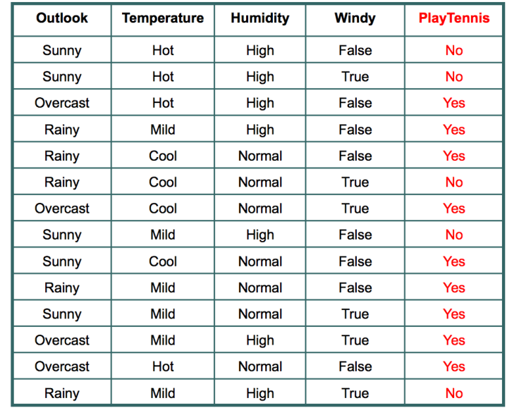
Background & Explanation
It is time to construct decision trees! But not just any decision trees: we want decision trees that are as small as possible. How do we do this? We maximize the entropy lost, or in other words, maximize the information gained from each choice in the tree.
Let’s do an example. Consider the PlayTennis training set on the right.
The measure of the entropy of this data set’s outcomes is the negated sum over each possible outcome of the probability of that outcome times the information content of that outcome, which is the log base 2 of the probability of that outcome.
In other words, the starting entropy of this data set is:
$$-1\left(\frac{5}{14}∙\log_{2}\frac{5}{14}+\frac{9}{14}∙\log_{2}\frac{9}{14}\right)= .9403$$
…since “No” has a 5/14 chance of happening and “Yes” has a 9/14 chance of happening.
(The derivation and explanation for this formula is in the part 2 activity’s textbook reading; I highly recommend revisiting that reading and the example problems & solutions posted on Piazza until the above calculation is clear!)
So what we want is to reduce the entropy as much as possible by making the best choice of feature each time. (Recall that any data set with only one outcome has an entropy of zero, so we want to minimize entropy as we go.)
So: how can we measure this? What does it mean to maximize information gained?
The basic idea here is that we want to be able to calculate the expected entropy if we know the value of a particular feature. Think of this like expected value in a probability problem – the odds of each outcome * the value of that outcome. We will find the odds of each value * the entropy of the corresponding data set.
Note: we must make a particular assumption here, which is that the chances of each value of a feature are approximately equal in reality to their proportion in the training set, but given this quite reasonable assumption, the calculation is straightforward.
To find the expected entropy of knowing the value of, say, Outlook, we would consider each possible value of Outlook, consider only the feature vectors in the table with that particular value for Outlook, find the entropy of that data set, and multiply it by the likelihood of that value. For instance, we would look at only the rows of the table with a “Sunny” outlook, find their entropy, and multiply by the odds of a “Sunny” outlook occurring.
In the case of Outlook, considering “Sunny”, “Overcast”, and “Rainy” in that order, the calculation is:
$$\frac{5}{14}∙.9710+\frac{4}{14}∙0+\frac{5}{14}∙.9710= .6936$$
You should verify each entropy calculation I made here; make sure you understand where these numbers come from. This math MUST make sense for this assignment to work; don’t turn the page until you’re clear on this calculation!

Warm-Up Exercise: Make sure you can correctly calculate information gain
On the previous page, you’ll note that .6936 is a much smaller value than .9403. Does that make it a good choice for the first node in our tree? Well, that depends on the expected entropy we’d get from knowing the value of each other feature…
By choosing Outlook, we would have an information gain of .9403 - .6936 = .2467.
Either by hand or using code, verify the information gained from each choice of feature in the PlayTennis dataset.
You should get:
Outlook | .2467
Temperature | .0292
Humidity | .1518
Windy | .0481
Which feature should comprise our first node, and why? Looking at the discussion from the first activity on Piazza, does this answer make sense?

Essential Task: Generate ideal decision trees
If you understand how to use the above process to decide on the first node of the tree, then the entire algorithm should now be clear: simply a recursive application of this process.
The recursive algorithm should:
- Consider each feature in turn. Find the information gain from differentiating based on that feature.
- Choose the feature with the highest information gain.
- Split the dataset into smaller datasets based on the possible values of the chosen feature.
- If any of the resulting datasets has an entropy of 0, then it is a leaf.
- Otherwise, recur on any smaller dataset with an entropy > 0.
The goal is to turn the PlayTennis dataset on the front into precisely the tree below, output in precisely the format shown below. (Note that the ordering of the options may be different, but the same flow must be present. So, Outlook must be the first choice, a rainy outlook must then split on Wind, etc.) On the right, my tree also prints out the information gain and entropy at each step for you to use in debugging & verification.
* Outlook?  * Overcast --> Yes  * Rain  * Wind?  * Weak --> Yes  * Strong --> No  * Sunny  * Humidity?  * Normal --> Yes  * High --> No | * Starting Entropy: 0.9402859586706311  * Outlook? (information gain: 0.24674981977443933)  * Overcast --> Yes  * Rain (with current entropy 0.9709505944546686)  * Wind? (information gain: 0.9709505944546686)  * Weak --> Yes  * Strong --> No  * Sunny (with current entropy 0.9709505944546686)  * Humidity? (information gain: 0.9709505944546686)  * Normal --> Yes  * High --> No

If we were in class, I’d have you generate the tree on the right and get a signature that the numbers were correct; in this context, you’ll have to check yourself!
An important note: notice in the run on the right that the entropy at “Rain” is actually higher than the beginning entropy. Why is this ok? Well, since it’s a leaf, the entropy at “Overcast” is zero! So even though two possibilities for Outlook increase the entropy of the resulting data set, overall that one option lowers the overall expected entropy a lot!
On the page where you downloaded this assignment, you’ll find several data sets. I’d like you to build trees based on three of them. For further data verification, this is the tree generated from the WillWait dataset:
* Patrons?  * None --> No  * Some --> Yes  * Full  * Hungry?  * No --> No  * Yes  * Type?  * Burger --> Yes  * Thai  * Friday/Saturday?  * No --> No  * Yes --> Yes  * Italian --> No | * Starting Entropy: 1.0  * Patrons? (information gain: 0.5408520829727552)  * None --> No  * Some --> Yes  * Full (with current entropy 0.9182958340544896)  * Hungry? (information gain: 0.2516291673878229)  * No --> No  * Yes (with current entropy 1.0)  * Type? (information gain: 0.5)  * Burger --> Yes  * Thai (with current entropy 1.0)  * Friday/Saturday? (information gain: 1.0)  * No --> No  * Yes --> Yes  * Italian --> No

Your specific task:
- Verify that the PlayTennis dataset produces precisely the tree on the preceding page.
- Verify that the WillWait dataset produces precisely the tree shown above.
- Generate a tree using the ToxicMushroom dataset (which answers the question “should I eat this mushroom?”) If this were class, I’d have you submit this to me, but for now let’s use the Student Answer feature on Piazza. Either post your tree in the Student Answer section or, if a tree is already there, verify that the posted tree is correct, adding “I can verify that this is correct” to the Student Answer or posting a corrected tree.
Once you’ve verified that your ToxicMushroom tree is correct against the Student Answer, you’re ready for the next assignment; the rest of this document is advice and an optional (very cool) extension. The next assignment will cover using decision trees to do what we actually want them to be useful for: predicting the outcomes on new data. We’ll look at techniques to maximize effectiveness and avoid overfitting. For now: just generate them correctly!

Implementation advice
If you’re particularly excited for a challenge, you don’t need to read any of this – everything you need to know to complete this assignment is in the sections above. But since we’re all working on our own, some FAQs / good advice:
- Don’t worry about efficiency. The data sets we’ll use, even the biggest ones, aren’t big enough for speed to matter. Any solution you write will almost certainly be fine.
- Split this into several helper functions and test them one by one. In addition to the core recursive function, you probably want a function just to find the entropy of the outcomes of a particular data set, a function to reduce a data set based on a particular value of a particular feature, and a function to choose the feature on the data set with the greatest information gain.
- Put some thought into how you want to store your tree. Generating the tree, and getting the output given above, isn’t trivial. You can code up a node class like we did in APCS (though note that the nodes only need to point to children; you’ll never have to traverse up the tree), or you can use something like nested dictionaries (dictionaries of dictionaries), or there are more counterintuitive ways that might be simpler. For instance, you could store your tree as a list – each element of the tree in the output order shown in the outline view above! Each element would need to be stored with a depth. This has the side-effect of making output much easier – just print " " * depth to get the indentation effect. Lots of possibilities here, but choose one carefully.
- Don’t worry about removing features from the vectors as you use them. Once you’ve split the data set on a feature, choosing that feature again will result in information gain of… zero! So it will never be chosen.

Totally awesome extension: Connect Four!
Here’s a wacky and kind of fascinating use of the decision tree functionality.
If you don’t know how Connect Four works, google it and play it for a few minutes and then come back.
Define a forced move to be a situation where one player must play in a certain cell in order to prevent the opponent from making a four-in-a-row on the next turn. Let us take as given that the choice an AI must make in this situation is obvious.
For all the rest of the decisions, the connect four dataset on Piazza contains every remaining valid board that can occur along with whether player one should win or lose from that position with perfect play. (The source is also on Piazza; follow the link and read more about how the dataset is formatted.) The value of every space on the board comprises an input vector; “win” or “lose” comprises an outcome… This is a classification problem!
Your task:
- Model Connect Four so that the game is playable.
- Code AI functionality to detect forced moves as described above and move appropriately.
- Use the given dataset to generate a decision tree.
- Code AI functionality to use the decision tree in all non-forced situations. (That is, in a non-forced situation, it should try all available moves, look them up in the decision tree, classify them as winning or losing, and play appropriately.)
Then, watch as the AI absolutely destroys you…
But wait, there’s more.
If you think about it, so far, this isn’t that impressive; we could, for example, duplicate this functionality with just a lookup table of board strings to “Win” or “Loss” values.
What’s really interesting here is that your tree has found the most important spaces to check, so if you don’t have the space to store every possibility, what you’ve done is prioritize what matters most.
So, to really get interesting…
- Measure the size of your tree. How many nodes? What’s the maximum depth? (This alone is interesting! On average, how many spaces does the AI really need to check to decide if a board is winning or losing?)
- Now, let’s intelligently reduce the size of the tree. Define a target entropy that’s greater than 0 and, whenever any node has entropy less than the target, just take the most prevalent value in the resulting data set and set that as the value of a leaf at that location. (Essentially, if we reach a point in the tree where 10 remaining data points are “Win” and only one is “Loss”, we can say that’s close enough, this node is “Win”.) This will generate some errors, to be sure, but how much do they matter? Adjust this value aiming for a tree half the size of what you originally had.
- If the approach in #6 is unappealing, you can also simply limit the size of the training set. Choose a random half of the input vector / output pairs in the data set. Build a tree just on those. See how much smaller it is.
- Pit your reduced tree against random, or try to play against it yourself. How often does it win? (Note that your “random” strategy should still play correctly on any forced move, otherwise this is far too easy!)
The ideas in this extension will come back in the next assignment where we’ll do some more precise quantifying of their effects. For now, play around – see what interesting things you can find!

